Task 18

Question 1: Facebook

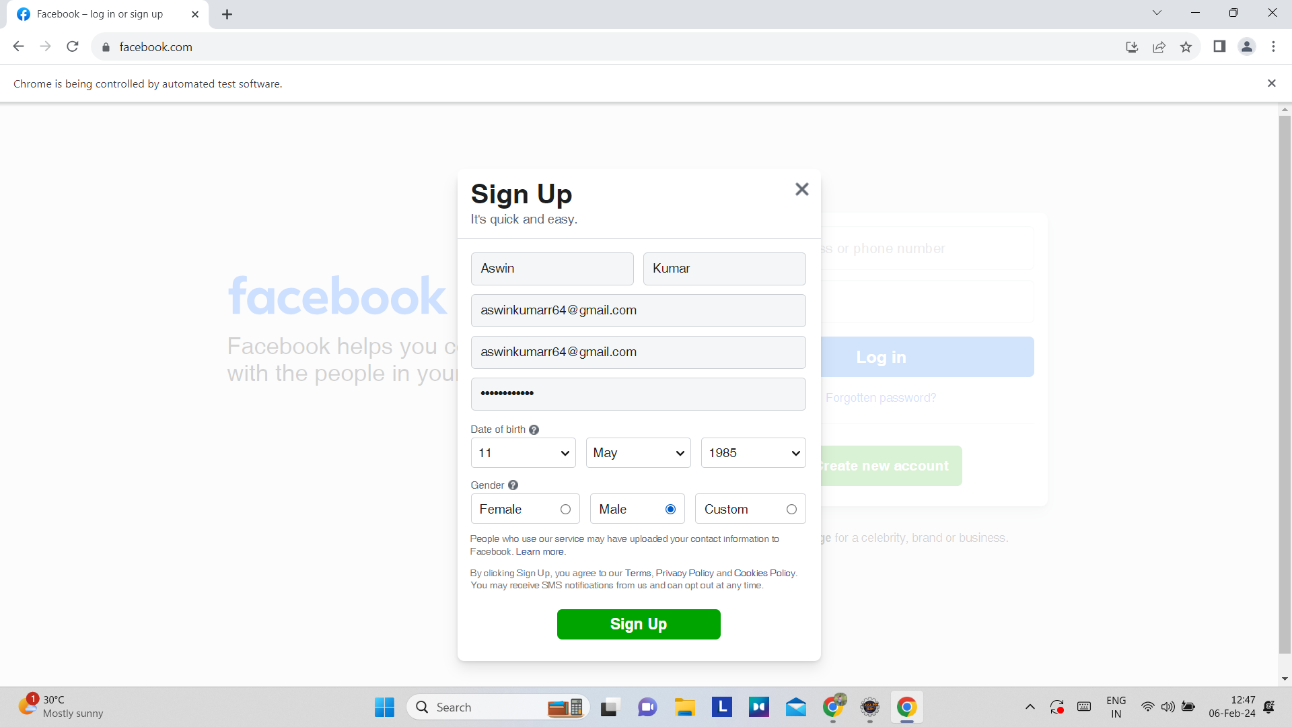

Screenshot showing all the required fields are filled

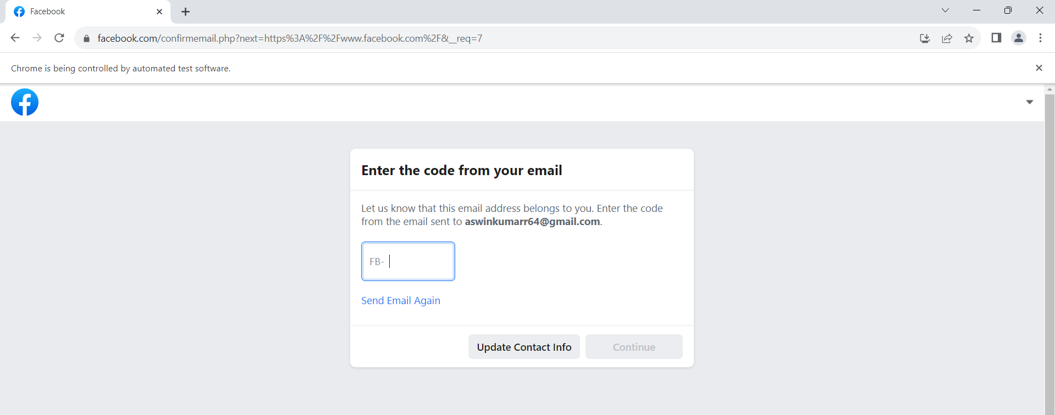

Account is created and being asked for email verification

Since entering email verification code cannot be automated, doing the task til filling the details and clicking the Submit button as per trainer’s advice

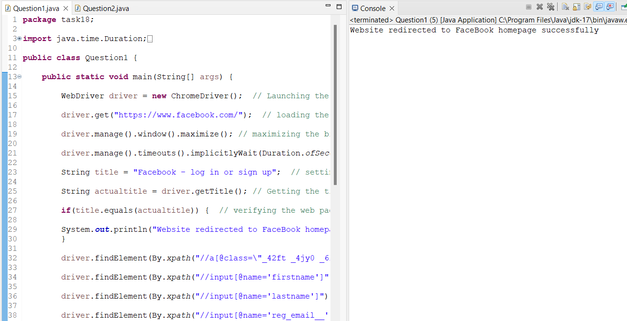

Console output

Question 2: Drag and Drop action

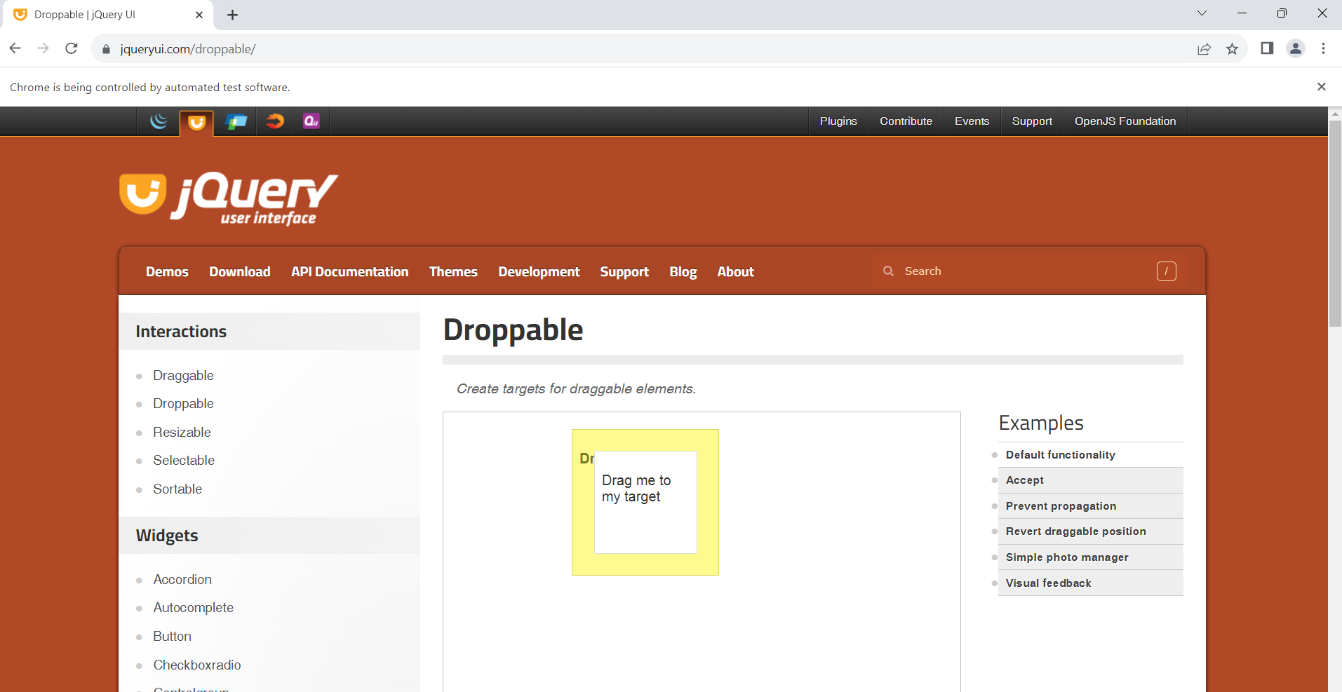

Screenshot shows the execution of drag and drop operation

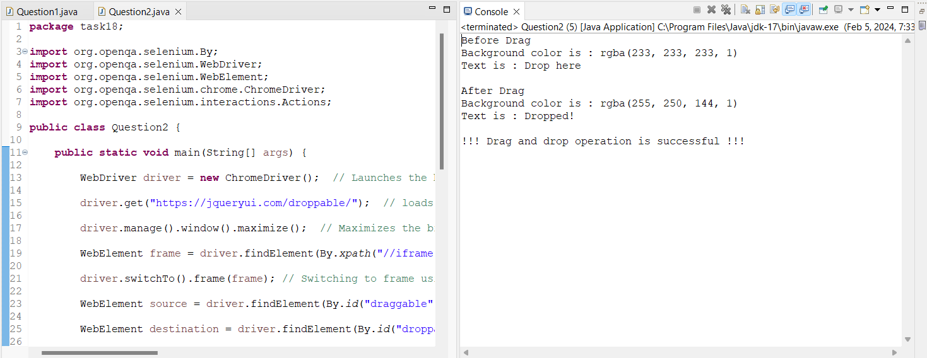

Console output verifying the action being done